# Connection Figure

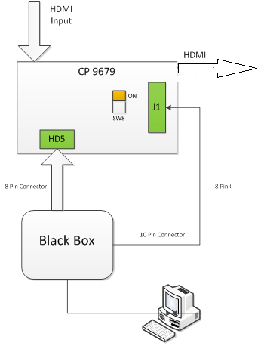

1. Connect Black Box 8 Pin connector (I2C and UART) to HD5 of start kit
2. Switch SW8 to ON
3. Connect Reset , INT and GND pin to 10 Pin connector of Black Box

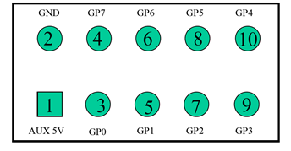

1. RESET: J1 Pin1 🡪 BlackBox Pin3(GP0)
2. INT: J1 Pin3 🡪 BlackBox Pin5(GP1)
3. GND: JP25 Pin GND 🡪 BlackBox Pin2(GND)

Below is a connected sample:

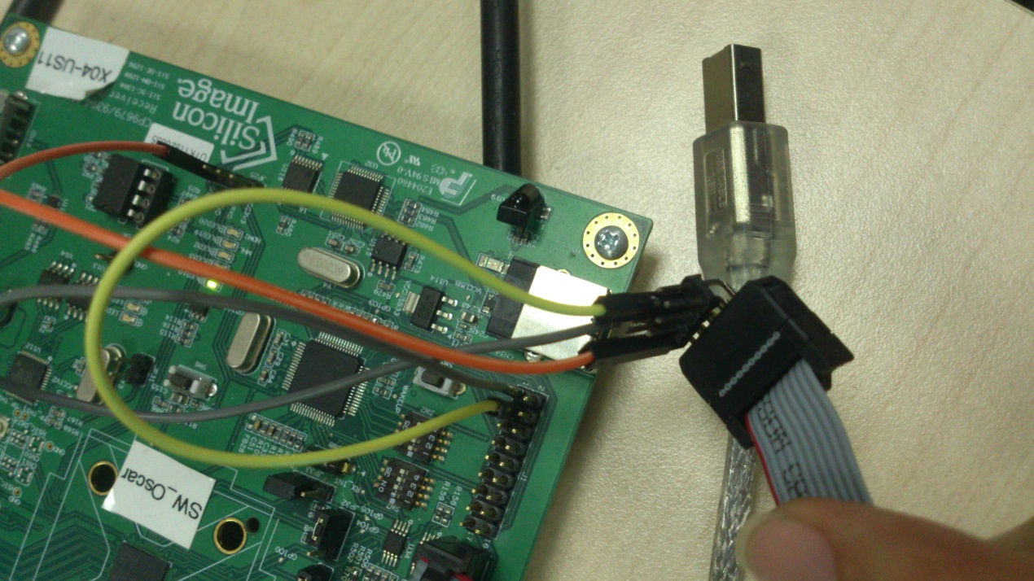

# Python Environment Setup

1. Because the dll file is 32 bit, so Python should also be 32bit.
2. Writing test code according to sample.py. Make sure your script file, _rogue.py and BlackBox.ini in same folder.
3. Run your script and check the result.

# How to build _rogue.py

1. Installation ctypeslib with below command:

easy_install ctypeslib==dev

1. Copy all C headers file under \husky\sample\rogue\src\Rogue_API to one folder.
2. Install VistualStudio 2005
3. Install gccxml-0.9.0-win32-x86.exe
   1. Add its installation location “C:\Program Files(x86)”\gccxml 0.9\bin” into PATH environment variable.
   2. Set GCCXML_COMPILER="C:/Program Files (x86)/Microsoft Visual Studio 8/VC//bin/cl.exe" in C:\Program Files(x86)\gccxml 0.9\share\gccxml-0.9\gccxml-config
4. Copy BlackBox.dll, ftd2xx.dll and Rogue_API.dll to C:\Python27
5. Run following commands:

cd C:\python27

python Scripts\h2xml.py D:\RogueAPI_Header\Rogue_API.h -o RogueAPI.xml -q -c

python Scripts\xml2py.py -c -d -k defst -l Rogue_API.dll -o _rogue.py -m ctypes.wintypes RogueAPI.xml

1. Now, you can find _rogue.py under C:\Python27

You can use PC 172.16.132.130 to do the build.

Reference: <http://starship.python.net/crew/theller/ctypes/old/codegen.html#overview>.